FastReport Encryption/Decryption Support

# Requirement

Make encryption and decryption functions available in FastReport.

# Overview

We have fields 'Encrypt' and 'Decrypt' in the Axpert product, which work at the .NET layer. As a result, data saved in the database appears encrypted in FastReport during fetch operations. To handle this (Decrypt), we added user functions into FastReport.

# Functionality

We added user functions into FastReport to handle encryption and decryption of Axpert field values. These functions invoke AxpEncryptData.DLL (a .NET type library) and agilecall its exposed 'Encrypt' and 'Decrypt' functions.

This has been handled in both AxFast and ASBScript.

## AxFast

For designing the template (design time), we included encrypt and decrypt functions in AxFast 11.0.

## ASBScript

To handle encryption and decryption at runtime, we included the required functionalities in ASBScript.

# Common Changes

We used LoadLibrary to load the AxpEncryptData.DLL, a .NET class-type library that has encrypt and decrypt functions. We registered FastReport user functions to make custom functions available inside FastReport, usable at both design time and runtime.

# How to Use Encrypt & Decrypt Functions Inside FastReport

## Using Expression

Encryption:

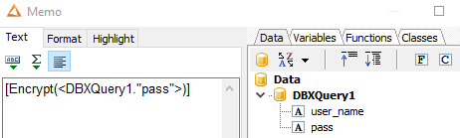

Decryption:

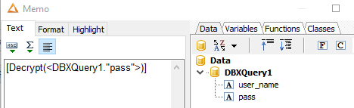



Preview:

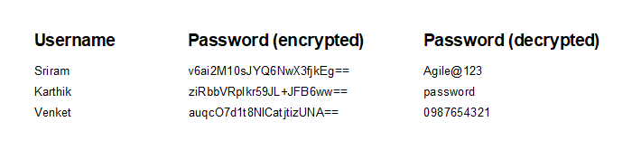

## Using Code

Encryption:

Encrypt (‘string value’)

Decryption:

Decrypt (‘string value’)

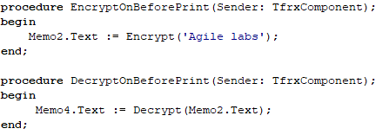

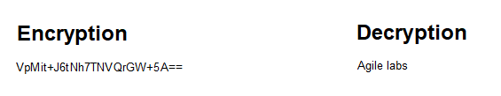

# Summary

These changes enable FastReport to use custom Encrypt/Decrypt functions by:

1. Loading the AxpEncryptData.dll at initialization
2. Registering custom FastReport user functions
3. Implementing the user function handler to process encryption/decryption requests
4. Providing wrapper functions in uGeneralFunctions to interface with the .NET DLL
5. **ASBScript**: Runtime support for encryption/decryption in report generation
6. **AxFast**: Design-time support for encryption/decryption in template design

# Important Notes

1) AxpEncryptData.DLL must be placed in the location where AxFast.exe is running  
2) AxpEncryptData.DLL must be placed in the location where ASBScript.dll is placed.  
3) AxpEncryptData.DLL is already made available in the 11.4 release.